
LESSON NOTE | DETAILED EXPLANATORY NOTES
POPULATION ECOLOGY
ENERGY FLOW, FOOD WEBS & ECOLOGICAL PYRAMIDS
GRADE 12 - BIOLOGY
■ ■ ■

Energy Moves Through Ecosystems
Every living thing needs energy, and almost all of it comes originally from the Sun. Green plants capture sunlight by photosynthesis, and this energy then passes from one organism to the next as they feed. Studying energy flow shows how energy moves through an ecosystem, while food chains and food webs map who eats whom, and ecological pyramids show how much energy (or how many organisms) there is at each level.
A key idea is that energy flows one way and is gradually lost as it passes along - unlike matter, which is recycled. This lesson explains trophic levels and the 10% rule, how to read food chains and webs, and the meaning of ecological pyramids, with Papua New Guinea examples. It is a core topic in the Population Ecology strand.
Why This Matters
- Energy flow explains how ecosystems are powered and structured.
- Food webs show how species depend on one another.
- The 10% rule explains why there are few top predators.
- It underpins farming, fishing and conservation decisions.
Energy Flow, Food Webs & Pyramids
Key Learning Outcomes
By the end of this lesson, students should be able to:
- Describe how energy flows through an ecosystem from the Sun.
- Define trophic levels: producers, consumers and decomposers.
- Explain the 10% rule and why energy is lost between levels.
- Construct and interpret food chains and food webs.
- Describe and interpret ecological pyramids (energy, numbers, biomass).
Trophic Levels and Energy Flow
Organisms are grouped into feeding levels called trophic levels. Producers (green plants) make their own food from sunlight. Primary consumers (herbivores) eat producers; secondary consumers (carnivores) eat herbivores; and tertiary consumers (top carnivores) eat other carnivores. Decomposers (bacteria and fungi) break down dead matter at every level, recycling nutrients. Energy flows from the Sun → producers → consumers, but at each step, much energy is lost as heat through respiration, and in movement and waste - so only about 10% of the energy passes to the next level. This is the 10% rule.
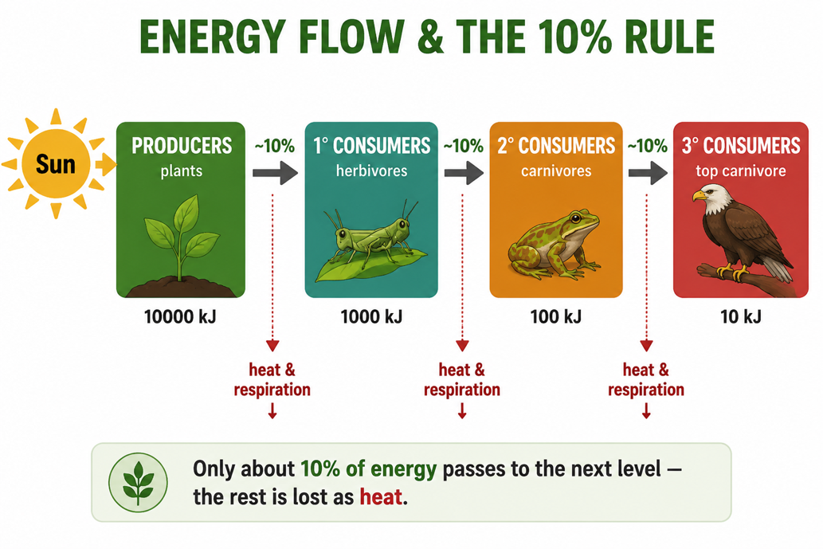
Figure 1: Energy flow and the 10% rule - most energy is lost as heat, so only about 10% passes to the next level.
Terminologies and Concepts
Useful terms for this topic:
- Producer: an organism (green plant) that makes food by photosynthesis.
- Consumer: an organism that eats other organisms (herbivore/carnivore).
- Decomposer: breaks down dead matter, recycling nutrients.
- Trophic level: a feeding level in a food chain.
- Food chain / food web: a single feeding path / many linked food chains.
- 10% rule: only ~10% of energy passes to the next trophic level.
- Ecological pyramid: a diagram of energy, numbers or biomass at each level.
Food Chains and Food Webs
A food chain shows a single feeding path, for example: grass → grasshopper → frog → snake → hawk. The arrows point from the food to the feeder, showing the direction that energy flows. In reality, most animals eat more than one kind of food and are eaten by more than one predator, so many food chains link together into a food web. Food webs are more realistic: they show that if one species is removed, many others are affected, because they are all connected. This is why losing a single species can disturb a whole ecosystem.
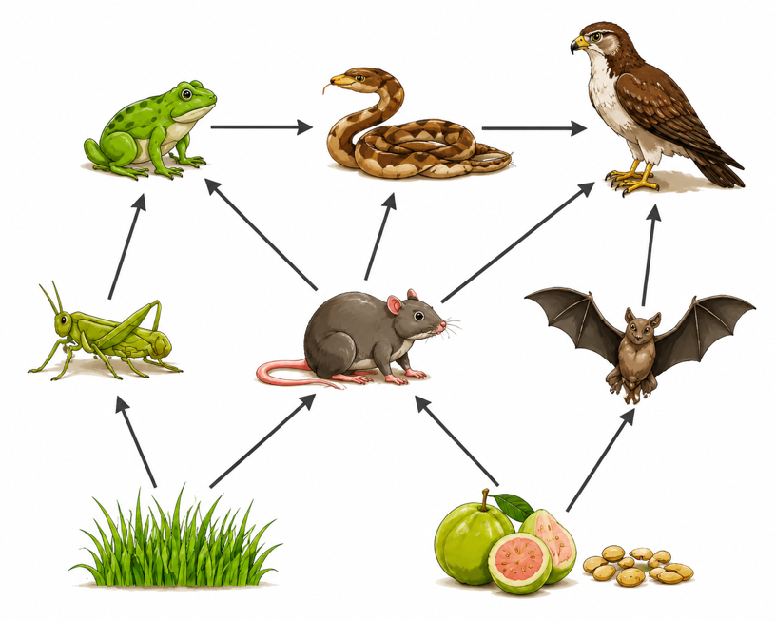
Figure 2: A simple food web - many food chains linked together; arrows point from food to feeder.
Ecological Pyramids
An ecological pyramid shows how a measured quantity changes up the trophic levels. In a pyramid of energy, each bar shows the energy available at that level; because of the 10% rule, each level up has far less energy, giving a pyramid shape with a wide base (producers) and a narrow top (top carnivores). There are also pyramids of numbers (how many organisms) and pyramids of biomass (the total mass of living material). All three usually taper upwards, showing that ecosystems can support many producers but only a few top predators.
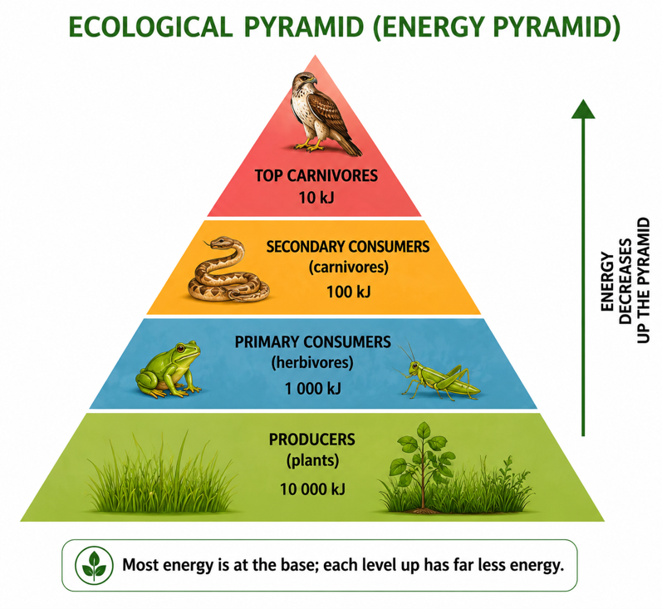
Figure 3: A pyramid of energy - most energy is at the producer base, decreasing at each level up.
Why the 10% Rule Matters
The 10% rule has important consequences. Because so much energy is lost at each step, food chains are usually short - rarely more than four or five levels - as there is not enough energy left to support many higher levels. It also explains why top predators are rare and need large territories. And it shows why eating lower on the food chain (plants, or plant-eating animals) feeds more people than eating top carnivores: less energy is lost, so more of the Sun's energy reaches us. This idea is central to understanding food supply and sustainability.
Why This Matters
- Ecosystem structure - energy flow explains how communities are built.
- Food security - the 10% rule affects how efficiently we can feed people.
- Conservation - food webs show why every species matters.
- Fisheries and farming - depend on understanding energy and feeding levels.
PNG Context Example
Energy flow shapes Papua New Guinea's ecosystems. In the rainforest, plants are producers feeding insects, cassowaries, tree kangaroos and fruit bats, which in turn feed pythons and birds of prey - a rich food web whose links keep the forest healthy. In coral reefs and rivers, algae and plankton are the producers that ultimately support the fish people depend on. The 10% rule helps explain why overfishing top predators, or clearing forests, can damage the whole system. Understanding these ideas supports sustainable fishing, gardening and conservation of PNG's exceptional biodiversity.
References & Related Documents
Source Documents
- PNG Biology Syllabus (SBC), Grades 11 & 12 - Strand: Ecology / Population Ecology; investigate energy flow, food webs and ecological pyramids in ecosystems.
- STEM Biology Syllabus - Grade 12. Thema: Ecology; Module: Population Ecology - Energy Flow and Ecosystems. Department of Education, PNG.
Further Reading & References
- OpenStax Biology - Energy Flow through Ecosystems; Food Chains and Food Webs; Ecological Pyramids. https://openstax.org/books/biology
- Khan Academy - Energy flow and primary productivity; trophic levels. https://www.khanacademy.org/science/biology/ecology

